DF_8

Part One
- Discuss why women experience higher rates of abuse or intimate partner violence. Include traits unique to the women, their place in society, or other appropriate factors.
- Explain strategies that can help a woman move beyond her situation and why they may or may not work.
- Finally, consider the following: If women with a history of abuse use violence against their abusers, should it be considered partner abuse or self-defense? Support your position with appropriate references.

Part Two
Now that we have examined women’s experiences with intimate partner violence and abuse along with strategies to help them, consider the following:
- There is another population of women who not only experience violence, but healthcare disparities as well. They are the LGBT population. In discussion, consider why this occurs and identify or propose possible solutions.

DF_9

Part one
How much do you know about menopause? Go to and peruse the Menopause Condition Center page at ThirdAge.com. Then take the Menopause Quiz: Symptoms & Signs found on the MedicineNet page to see how much you know about this event. (You do not have to register.) Share something you learned from taking the quiz.

Part two
Health risks for women change after menopause. Research the following sites and discuss what long-term health concern after menopause is the greatest risk for women.
http://www.menopause.org/
https://www.plannedparenthood.org/learn/health-and-wellness/menopause

Part three
In Module 3, we discussed having a menarche party. How do you feel about a menopause party? If so, what would you like to have happen?
DF_10
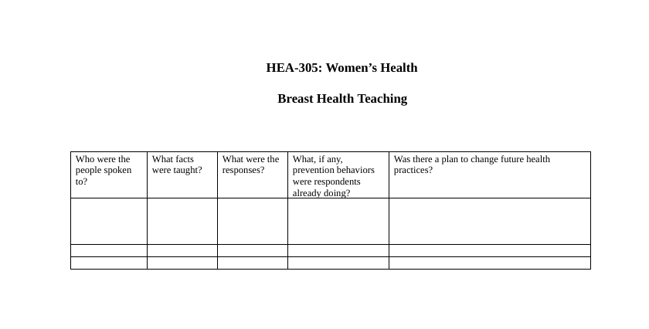
After reading pages 280–301 in Alexander, LaRosa, Bader, Garfield, and Alexander, New Dimensions in Women’s Health, review the information and recommendations from the National Breast Cancer Foundation website. Take the information and discuss breast health with two other women. You can do this at work, at home, with a neighbor―with whomever’s attention you can get. Use some of the information and recommendations from the National Breast Cancer Foundation website(https://www.nationalbreastcancer.org/about-nbcf). Share facts and recommendations with the two women you engage. See the Breast Health Chart below for a sample chart to help you complete this portion of the discussion activity.
Share the facts you used, and summarize your discussion with the two women. Were they aware of the facts? Did they have concerns for themselves? Have they had a mammogram recently? Do they do self-breast examination? What impact, if any, has breast cancer had on their family?

